STATEMENT OF WORK

This Statement of Work (“SOW”), effective as of 24 October 2025 (“SOW Effective Date”), is entered into by and between Takeda Pharmaceuticals International AG, a company incorporated in Switzerland under identification number CHE-113.444.401, having its registered office at Thurgauerstrasse 130, 8152 Glattpark (Opfikon), Switzerland (“Takeda”) and Altimetrik Corp, a company incorporated in Michigan, USA, with registration number 800029966 , having its registered office or principal place of business at 1000 Town Center, Suite 700, Southfield, Michigan, 48075 (“Company”). This SOW is incorporated into and shall be governed by the Master Services Agreement by and between Takeda and Company dated March 1, 2023 (“Agreement”). Capitalized but undefined terms shall have the meanings first ascribed to them in the Agreement.

- TAKEDA Project NUMBER: 1063647

- PROJECT NAME: GSQ DD&T Roadmap Executive Platform

- Project Initiation Date: 01st Oct 2026

- Project Completion Date: 31st Dec 2026

- Description of Services & Deliverables:

Project Overview
The Company shall provide Time & Material technical-delivery services for an integrated GSQ GML DD&T Roadmap Executive Platform Minimum Viable Product (MVP). The MVP shall include all three platform components and shall use Jira, SPOT, and EDB as required data sources from the outset.

1. Integrated MVP Scope
Required component | MVP scope | Required data sources
1. GSQ DD&T Roadmap | Executive portfolio health, initiative tracking, roadmap visualization, milestones, delivery status, investment context, risks, dependencies, and drill-down dashboards. | Jira, SPOT, and relevant EDB data
2. Thousand Oaks Business Review pilot | Pilot site experience for initiative status, delivery and investment measures, KPIs, executive-review workflows, site views, and reusable business-review patterns. | Jira, SPOT, and relevant EDB data
3. Business Capability / North Star deployment, integration and adoption (Digital Maturity) status | Business-capability deployment, North Star deployment, adoption, utilization, maturity indicators, and value-realization experience integrated with portfolio and investment context. | EDB with relevant Jira and SPOT context
MVP boundary: The working MVP, testing, pilot evaluation, and acceptance shall represent all three components and all three required data sources. Any limitation in source access, quality, integration, or functionality shall be documented in the MVP Assessment Report and shall not be described as accepted unless approved by the designated Takeda acceptance authority.

2. Services and Technical Delivery Scope
- Technical discovery and detailed solution design, including architecture, data flows, integration patterns, environments, non-functional requirements, and delivery controls.
- TakOS front-end development for navigation, dashboards, filters, drill-downs, role-based experiences, and the integrated presentation of the three MVP components.
- TakOS back-end development, services, business logic, APIs, reusable components, and application-layer data models needed to support the working MVP.
- Data engineering and data-product work for Jira, SPOT, and EDB, including approved ingestion or access patterns, transformations, mappings, lineage, quality checks, freshness assessment, and documented limitations.
- API and integration design and implementation, including source-system interfaces, TakOS services, error handling, monitoring, and technical documentation.
- Security design and implementation aligned with Takeda requirements, including access controls, identity integration, authorization, secure configuration, logging, and required reviews.
- Functional, integration, data-quality, security, regression, performance, and user-acceptance testing support; defect triage; release readiness; and evidence capture.
- Deployment and environment promotion using Takeda-approved SDLC, qualification, change, DevOps, and release controls applicable to the solution.
- Thousand Oaks pilot support, user feedback capture, issue resolution, hypercare within the SOW period, and reuse assessment.
- Technical, operational, support, data-lineage, configuration, API, security, testing, deployment, and user documentation; knowledge-transfer sessions and handoff.
- An MVP Assessment Report and an evidence-based roadmap for Releases 1 through 3, including validated findings, gaps, dependencies, risks, architecture recommendations, prioritized features, scale considerations, ownership and support-model recommendations, and planning assumptions.

3. Responsibilities and Accountability
Takeda / GML business-design responsibilities | Altimetrik / TakOS technical-delivery responsibilities
Define business outcomes, personas, decisions, workflows, user journeys, screen inventory, navigation intent, business rules, KPI definitions, calculation intent, value measures, prioritization, and business acceptance criteria. | Translate the approved business design into detailed technical designs, backlog items, estimates, sprint plans, solution architecture, data models, services, APIs, integrations, security controls, code, tests, deployments, and technical documentation.
Provide or approve the Business Design Package, mockups, source-system owners, data definitions, access requests, environments, governance contacts, SMEs, test users, and timely decisions. | Validate technical feasibility and source-data suitability; identify gaps and dependencies; implement Jira, SPOT, and EDB connectivity and data products using approved patterns; maintain delivery evidence and traceability.
Execute or formally approve UAT and business acceptance through the Takeda Product Owner | Support UAT, defect resolution, release readiness, deployment, pilot hypercare, documentation, knowledge transfer, MVP assessment, and Releases 1-3 roadmap development.
Retain accountability for business-process design and for confirming that the product supports intended leadership decisions. | Retain accountability for technical delivery quality. Altimetrik/TakOS shall not be required to invent unapproved business processes, KPI definitions, or business policy.

4. Measurable Deliverables and Acceptance Evidence
ID | Deliverable | Required evidence / measurable completion
D1 | Approved integrated MVP technical design | Architecture, component design, data-flow diagrams, interface inventory, security design, NFRs, environments, dependencies, and review decisions documented for all three components and Jira, SPOT, and EDB.
D2 | Prioritized and traceable product backlog | Epics and INVEST user stories mapped to the three components, three data sources, deliverables, acceptance criteria, owners, dependencies, and release/sprint plans.
D3 | Jira, SPOT, and EDB data products and integrations | Working approved connections or interfaces, mapped fields, transformations, lineage, quality/freshness results, exception handling, and documented source limitations.
D4 | Integrated TakOS MVP | Working front end and back end covering Roadmap, Thousand Oaks Business Review, and Business Capability / North Star experiences in a Takeda-approved environment.
D5 | Security and operational controls | Approved access model, identity/authorization implementation, logging/monitoring approach, security evidence, deployment procedures, and support/runbook content required for MVP use.
D6 | Testing and pilot evidence | Test plan, cases, execution results, defect log, traceability, UAT support evidence, Thousand Oaks pilot feedback, and release-readiness record.
D7 | Documentation and knowledge transfer | Current technical, data, API, integration, configuration, test, deployment, support, and user documentation plus completed knowledge-transfer sessions and handoff record.
D8 | MVP Assessment Report | Evidence-based assessment of feasibility, usability, data quality, performance, security, adoption, utilization, maturity, value-realization capability, limitations, risks, reusable patterns, and recommended go-forward decision.
D9 | Roadmap for Releases 1 through 3 | Prioritized roadmap grounded in MVP evidence, with release objectives, features, dependencies, risks, architecture and scale considerations, ownership/support recommendations, and planning assumptions; dates and funding are [TBD – Takeda/Altimetrik confirmation required].

5. Timetable and Milestones
All Services shall be performed within the contractual period of 01 October 2026 through 31 December 2026. Detailed milestone dates, sprint boundaries, release dates, and acceptance checkpoints shall be managed through the approved Agile delivery plan and sprint cadence established during project mobilization.
Milestone | Completion condition | Target date
M1 - Mobilization and scope confirmation | Governance, access plan, integrated MVP boundary, roles, dependencies, success measures, and delivery plan confirmed. | October 12, 2026
M2 - Technical design and backlog baseline | D1 and D2 reviewed; Jira, SPOT, and EDB integration approach and security dependencies confirmed. | October 26, 2026
M3 - Integrated build increment | A demonstrable TakOS increment includes each of the three platform components and evidence of each required data source. | November 27, 2026
M4 - Test and Thousand Oaks pilot readiness | D3-D6 are sufficiently complete for pilot execution and UAT under agreed entry criteria. | December 4, 2026
M5 - MVP completion and handoff | Acceptance criteria satisfied or exceptions formally approved; D7-D9 delivered; knowledge transfer and handoff completed. | No later than 31 December 2026, subject to agreed acceptance schedule

6. Dependencies and Assumptions
- Takeda will provide timely access to Jira, SPOT, EDB, TakOS environments, repositories, identity/security services, source-system SMEs, data definitions, and required review and approval forums.
- Takeda will provide the approved Business Design Package and timely business decisions, including KPIs, calculations, workflows, mockups, personas, prioritization, and business acceptance criteria.
- Jira, SPOT, and EDB contain or can expose sufficient approved data for MVP validation. Altimetrik shall validate this assumption and document evidence and gaps.
- All source access, API, security, privacy, compliance, GxP/non-GxP, architecture, and SDLC requirements remain subject to Takeda approval.
- Delays in access, decisions, environments, data availability, security review, or UAT may affect cost or schedule. Any change to fees, staffing, rates, or ceiling requires the contractual process for approved Additional Work.

7. Risks and Controls
Risk | Impact | Control / required response
Jira, SPOT, or EDB data is unavailable, incomplete, inconsistent, stale, or insufficiently structured. | High | Validate access, hierarchy, fields, relationships, quality, lineage, freshness, and availability early; document gaps and agreed responses in the backlog and MVP Assessment Report.
API, data-product, environment, or security approvals delay the integrated build. | High | Identify owners and lead times during mobilization; maintain a dependency log and escalate unresolved blockers through governance.
Six-week MVP expectations conflict with the October-to-December contractual period or with the required integrated scope. | High | Agree a dated integrated release plan and acceptance schedule before signature; preserve all three components and Jira, SPOT, and EDB in MVP acceptance.
Business design or acceptance decisions are delayed or incomplete. | High | Use decision logs, named owners, review cadence, and explicit entry/exit criteria. Missing owners or dates remain TBD.
Scope growth exceeds the approved T&M ceiling. | High | Prioritize within the integrated MVP boundary, maintain change control, and do not exceed the approved fees without written authorization under Additional Work.
Pilot users do not adopt or find value in the experience. | Medium | Test explicit leadership decisions, measure feedback and reporting effort, capture evidence, and address findings in the Assessment Report and Releases 1-3 roadmap.

8. MVP Acceptance Criteria
- All three platform components are demonstrable in the integrated TakOS MVP: GSQ DD&T Roadmap, Thousand Oaks Business Review pilot, and Business Capability / North Star deployment, adoption, utilization, maturity, and value-realization experience.
- Jira, SPOT, and EDB are each represented through working, Takeda-approved MVP integrations or data products, with documented mappings, lineage, quality/freshness evidence, error handling, and known limitations.
- End-to-end priority workflows and approved dashboards operate in the designated environment and are traceable to approved user stories and business acceptance criteria.
- Role-based access, identity/authorization, logging, security requirements, and required reviews are implemented or formally accepted as documented exceptions by the designated Takeda Product Owner, Business Sponsor, and Technical Lead.
- Functional, integration, data-quality, security, regression, and applicable performance testing are complete; UAT is completed under agreed criteria; no open blocker or critical defects remain. Treatment of lower-severity defects is documented and approved.
- The Thousand Oaks pilot is completed with recorded feedback and evidence addressing usefulness, usability, data confidence, reporting effort, and reuse potential.
- Documentation and knowledge transfer are complete and accepted, including technical design, data lineage, APIs, integrations, security, configuration, testing, deployment, operations, support, and user guidance.
- The MVP Assessment Report and evidence-based Releases 1-3 roadmap are delivered and accepted.
- Final acceptance authority shall be the designated Takeda Product Owner and Business Sponsor, with acceptance documented in writing following successful completion of agreed MVP acceptance criteria.

.

- Roles & Responsibilities
Enablement Team
Role​ | Responsibilities​
Program Management leader | - Responsible for end-to-end Program Management​  - Liaison with all stakeholders and help in arriving at the most optimal execution approach.  - Ensure engineering rigor across the program.  - Ensure smooth progress of the Execution Roadmap​  - Periodic program status updates to stakeholders​  - Support the design and refinement of technology stack and low level (detailed) technical design of solution together with other vendors
Data Architect | - Responsible for defining the data (migration) strategy for the Insight Center in alignment with EDB/DDM Data Strategy tailored around scalable, re-usable, high performing components and end-user services.  - Provide top-quality solution design and execution and providing support in defining the scope and sizing of work.  - Design and implement end to end scalable solutions such as data modelling, data loading and data governance on current and future platform.  - Integrate up-and-coming data management and software engineering technologies into existing data structures as a part of innovation of current platform.  - Support/enhance the overall improvement of the existing data platform.  - Improve data quality, data governance and operational standards, design and define monitoring and data integrity and data stewardship capabilities
QA Lead/ Architect | - Responsible for defining the validation approach for the Insight Center, its components and data in alignment with Takeda QA lead including data accuracy and completeness, record counts, and data integrity  - Responsible for creating test plan, test strategy and tooling integration & automation for the overall program covering the functional and integration touch points  - Responsible for ensuring test coverage for all the functional and integration touch points.  - Responsible for monitoring UAT Defects and collaborating with product manager during defect triage calls.  - Responsible for identifying the issues and ensuring the proper governance is put across the defect lifecycle and closure of all issues

Discovery Team
Role​ | Responsibilities​
Proxy PO/ PO Buddy/ BA | - Work as a bridge between business and IT to understand program goals and prioritize engineering activities​, gather and document user functional and non-functional requirements.  - Analyze current business / data logic and translates that into documentation for Product Owner and developers.  - Break down complex business stories into simple (INVEST*) user stories​Work with Scrum Teams to clarify Product related queries.  - Support identification of data lineage and ensure data requirements are clearly documented, shared and understood by DDM/ MAF teams

Scrum Master​ + Program Manager | - Define and run Scrum ceremonies.  - Responsible for Scrum team output; sprint-on-sprint based backlogs​.  - Identify and manage dependencies​.  - Raise risks, issues and ensure mitigations are in place​
Data Lead + Engineers​ | - Pick up data from the Data Mart and then create any transformations that may be needed before it is presented to the front-end  - Create and maintain optimal data pipeline architecture as per architecture design by Data Architect  - Support the accuracy of data transformations and data verification.  - Ensure compliance with data governance and security policies.  - Interpret trends and patterns, ensure scalability and encapsulation of transformations.  - Support the accuracy of data transformations and data verification, explore ways to enhance data quality and reliability.  - Ensure compliance with data governance and security policies.  - Ensure Data Lineage documentation according to Takeda standards  - Close alignment with DDM / MAF team on prioritization, timing, knowledge exchange
Back-End Developer | - Build backend components / services to deliver data to application frontend.  - Ensure proper code level and project level documentation.  - Define unit tests.  - Co-design and define API together with FE Developer/ Data Engineer ahead of time
Tester/ Quality Engineers​ | - Responsible for writing and execution of Test cases​  - Capture Test results and share it to relevant stakeholders​.  - Ensure deliverables are aligned with Product Backlog items​.  - Responsible for automating based on test strategy

AI Enabled Team
Key Deliverable | Outcome
AI Engineering Lead (Agentic Coding Lead) | Drive adoption of agentic/vibe coding practices, define team standards for AI usage, establish prompting & code review best practices, coach team on effective AI collaboration, ensure quality and consistency, monitor productivity & KPIs, enforce governance and responsible AI usage
AI Product Orchestrator | Frame problems clearly, prompt AI for requirements & workflows, iterate on outputs with stakeholders, ensure business logic accuracy
AI Pair Programmer / Code Curator | Decompose tasks for AI, prompt & iterate on code generation, validate and refactor outputs, debug AI-generated code, ensure maintainability and integration
AI Solution Architect | Generate and compare architecture options, define system constraints & guardrails, guide AI-driven design decisions, validate scalability and feasibility
AI Test Orchestrator | Generate test cases via AI, expand edge cases, validate coverage, simulate real-world usage, ensure system reliability
AI Experience Designer | Generate design concepts and variations, provide structured prompts and constraints, validate usability, accessibility, and consistency
AI Delivery Steward | Use AI for planning and tracking, monitor delivery progress, manage collaboration, track KPIs and outcomes
AI Ops & Automation Specialist | Automate CI/CD pipelines, monitor systems using AI, manage AI governance, optimize performance and reliability
AI Data Specialist | An AI Data Specialist prepares, manages, and analyzes data to support AI and machine learning solutions.  They ensure data quality, build datasets, and help transform raw data into reliable insights for AI models.
AI Data Modeler | An AI Data Modeler designs and structures data models that support AI, analytics, and machine learning use cases.  They define relationships, patterns, and data flows to make information accurate, scalable, and ready for AI solutions.

- Deliverables*
Key Deliverable | Outcome
Data Model | Scalable platform/application layer data models, documented data lineage, following data strategy and governance. Documented and tested. Passed SDLC/qualification
* The final deliverables will be agreed with Takeda Program Lead in accordance with release and sprint plans

Altimetrik Execution Methodology
Altimetrik proposes an Agile, Output-driven approach to drive iterative, incremental business relevant releases as minimum viable products. This is implemented via collaborative scrums following robust SOLID design principles supported by a high degree of quality engineering automation and flexible DevOps capabilities.
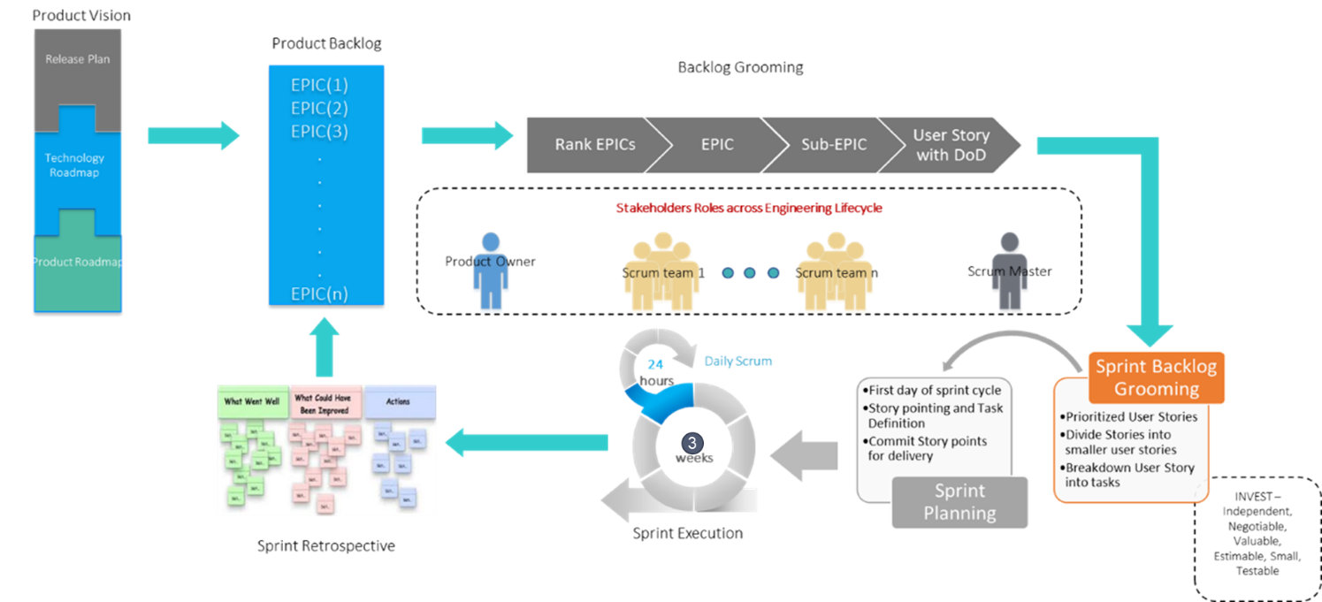
High level requirements are added as EPICs into product backlog based on product vision and same is run through a series of grooming sessions till the same is granulated enough to be considered a user story. A user story is the smallest portion of Independent, Negotiable, Valuable, Estimable, Small and Testable (INVEST) requirements that can be taken by an engineering scrum within a sprint and address.
The proposed development methodology is based on iterative releases. Scrums introduce agility into the process at various stages and use the “best fit” process based on the type of activities.
The following Scrums are proposed to implement this:
- Engineering Scrum delivering the User Stories as per sprint plan
- The Product Owner will define INVEST user stories.
“Acceptance Criteria” for User Stories will be defined and aligned between Product Owner and team adopting the following approach:
- Define boundaries: Acceptance criteria help development teams define the boundaries of a user story. In other words, acceptance criteria help us confirm when the application functions as desired, meaning that a user story is completed.
- Reach consensus: Having acceptance criteria synchronizes the development team with the Product Owner (Takeda). The team will know exactly what conditions should be met, just as the Product Owner would know what to expect from the User story. This will also provide enough documentation necessary for functional design and Testing Support.
- Serve as a basis for tests: Finally, acceptance criteria will act a cornerstone of positive and negative testing aimed at checking if a system works as expected.
- Allow for accurate planning and estimation: Acceptance criteria scenarios will allow for the correct division of user stories into tasks, so user stories are correctly estimated and planned.

“Definition of Doneness” is a global checklist for all the user stories, a shared understanding of what it means for work to be complete, to ensure transparency, which would mean each story when done.
- Will be demonstrable on a given environment.
- Will have enough documentation to support the story being delivered.
- Will have enough Testing embedded in the approach followed.
“Use case Exit Criteria” is the list of criteria that would define the completeness of a modules in scope for each Use case being implemented.
- Hand-off to UAT team after Code has been moved to Production environment.
- Takeda teams will define UAT (at the time of discovery) and execute them. UAT to be completed in the sprint following movement to Production – unless there are blockers impacting test found during the UAT. Altimetrik will attempt to quickly unblock and support the UAT continuation.
- UAT completion will be defined as test complete with no open bugs. Minor bugs, if any open, will be prioritized and fixed during the hyper care period.

The Insight Center program will leverage Takeda agile delivery methodology, guidelines, controls and workflows for GxP and non-GxP. This is binding for the program and this SoW. The program team will take Altimetrik’s thought leadership and expertise into consideration for enhancing and advancing the methodologies.

Execution Assumptions
The execution roadmap and team structure has been defined based on the following assumptions:
- Takeda shall ensure timely support from requisite stakeholders for validation, reviews, signoffs, and process flows etc. Any delays will impact cost and timeline.
- Takeda shall ensure sufficient knowledge transfer from current team.
- Takeda shall provide environment, infrastructure, and necessary access permissions to project teams in a timely manner.
- Support Coverage:
  - Support Days - Monday to Friday, excluding public holidays.
  - Support Hours - 10 AM IST to 7 PM IST. Teams working and interacting with US require to be available beyond 7 PM IST on a regular basis. The program will minimize impact where possible.

Governance Model
We approach the engagement with an Agile mindset, primarily focused on how the Takeda engineering ecosystem can successfully transform by adopting continuous learning / continuous improvement models. Together with Takeda, Altimetrik will establish a Governance team (contacts), reporting cadence, and associated roles & responsibilities prior to the beginning of the project and will be monitored by Altimetrik leadership team monthly. Altimetrik proposes the following Governance structure and will work with Takeda on integrating into one program approach.
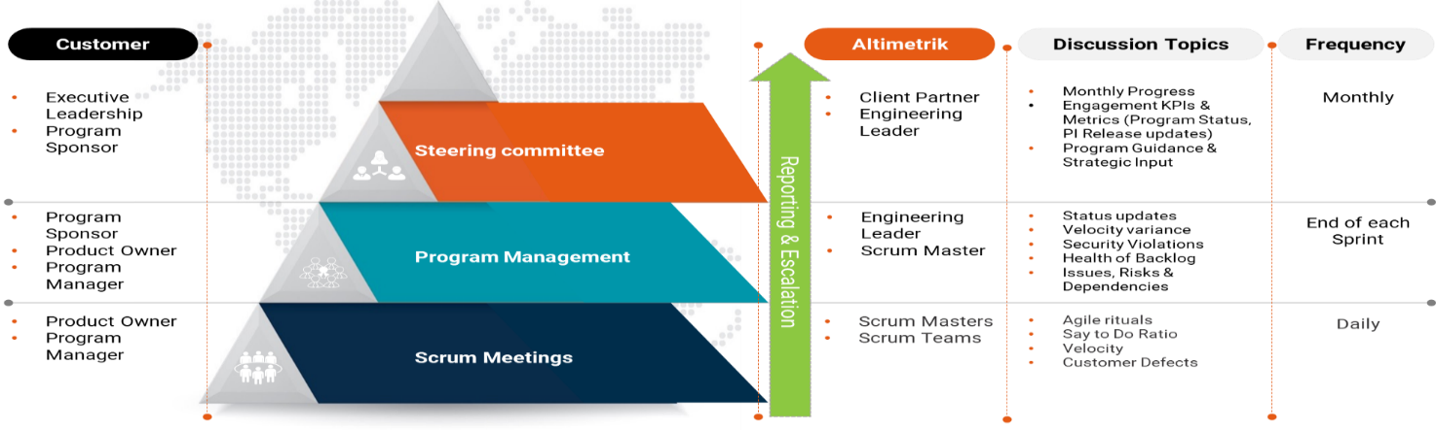

- Timetable and Project Milestones:

All Services are to be completed, and Deliverables delivered according to the release plan

- Key Personnel:

Key personnel: list the names and roles of Company’s key personnel who will provide the Services, including the name of Company’s manager responsible for the project.

Name | Responsibility | Duration of Assignment
Bipin Bhaskar | Client Partner | Oct’2026 to Mar’2027
Srinath Parthasarathy | Engineering Leader | Oct’2026 to Mar’2027

Roles and allocations per month (in FTE)

During the project roles and allocations may change based on project needs subject to Takeda Program Lead approval, as long as the total contracted fees are not exceeded.

- Budget and payment:
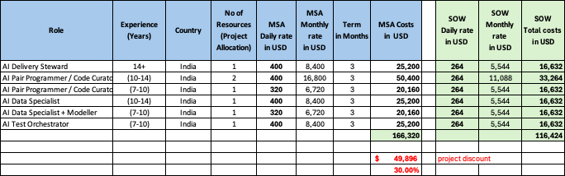

  - Maximum project budget: The overall cost of the team proposed in the table above is 116,424 USD.

  - Fees. In consideration for the Services that Company performs pursuant to this SOW, Takeda shall pay Company’s fees of 116,424 USD on a Time & Material for the above defined.

  - Payment Terms and Schedule. Company may invoice Takeda for the Fees and any Authorized Expenses as they are incurred but no more frequently than monthly. Company shall invoice only for Services that are complete and Deliverables that have been accepted by Takeda. Takeda shall pay each invoice it receives from Company in accordance with the terms of the Agreement.

All invoices should state the name of Dean Santaro, as the relevant Takeda contact.

Company shall send all invoices based on a purchase order (“PO”) electronically through Ariba Network. If it is not embracing Ariba Network, Company shall send scanned invoices directly to Takeda’s scanning partner as instructed by Takeda [Full instructions to suppliers and list of relevant email addresses are available here: Takeda TBS Guide to Payments for Suppliers].

  - Additional Work. Takeda may incur additional fees and expenses if it requests Company to perform services that are materially different from, or in addition to, those described in this SOW (“Additional Work”). Company must obtain Takeda’s written approval prior to commencing any such Additional Work or incurring any expenses in connection with such Additional Work. In order to seek Takeda’s approval for Additional Work, Company will notify Takeda that the requested services are outside of the scope of this SOW and will provide Takeda with an estimate of the corresponding additional fees and expenses.

(SIGNATURES TO FOLLOW ON NEXT PAGE)

Signature Page
Envelope Master EUCAN EM four signatures – NO OFFSET

AGREED AND ACKNOWLEDGED:

Takeda Pharmaceuticals International AG |  |  |  | Altimetrik Corp
By: |  |  |  | By:
 | (si1( |  |  |  | (sc1(
Name: |  | (ni1( |  | Name: |  | (
Title: |  | (ti1( |  | Title:
Place: |  | (pi1( |  | Place: |  | (pc1(
Date: |  | (di1( |  | Date: |  | (dc1(

Takeda Pharmaceuticals International AG |  |  |  | Altimetrik Corp
By: |  |  |  | By:
 | (si2( |  |  |  | (sc2(
Name: |  | (ni2( |  | Name:
Title: |  | (ti2( |  | Title:
Place: |  | (pi2( |  | Place: |  | (pc2(
Date: |  | (di2( |  | Date: |  | (dc2(

